**Team ID:** PNT2022TMID11701

**Project Name:** Gas leakage monitoring and alerting system for industries

**SPRINT 2**

**Steps:**

1. IBM IoT node is used to gather sensor data.

a. Necessary API key is provided to establish a connection.

2. Using functions namely Temperature, Humidity, and Gas the data is obtained independently and displayed on the dashboard. 3. Dashboard Nodes are used to display the sensed data to the user in a portal.

**Source code:**

**Temperature:** msg.payload=msg.payload.Temp; return msg;

**Humidity:** msg.payload = msg.payload.Hum;

return msg;

**Gas:** msg.payload = msg.payload.gas;

return msg;

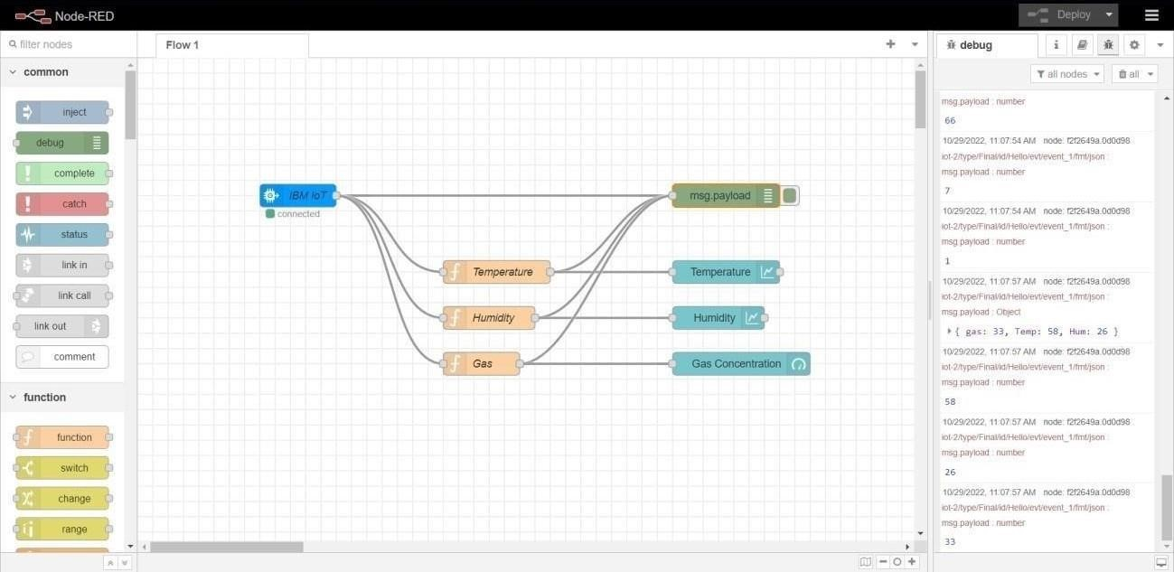

*Data is brought to Node-RED*